**Project Report Template**

**INTRODUCTION**

1.1 Overview

While creativity is vital,don’t forget to include essential details in the invitation. Make sure to **mention the date,time and location of the party,** **along with an RSVP contact.**If there’s a dress code or specific theme,be sure to convey that information clearly to your guests.

1.2 Purpose

Remember that the main purpose of party invitations is **To actually invite your guests.** Cute , personalized, themed invitations are fun, and can get people excited for the party. Just make sure you include all of the relevant information in a clear, legible way.

**Problem Definition & Design Thinking**

**2.1 Empathy map**

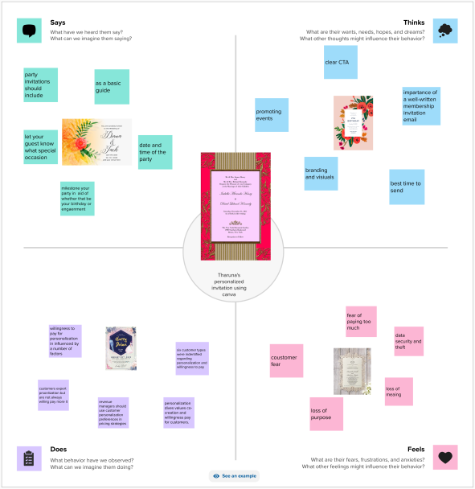

**2.2 Ideation & Brainstroming**

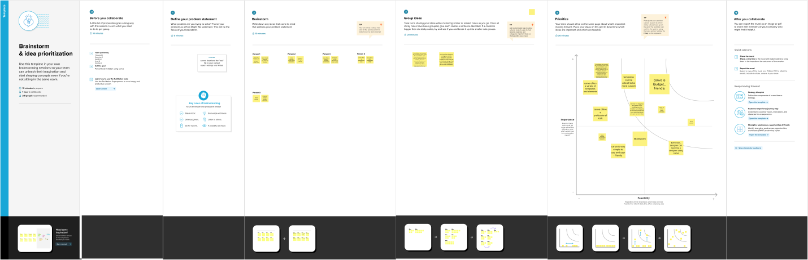

**RESULT**

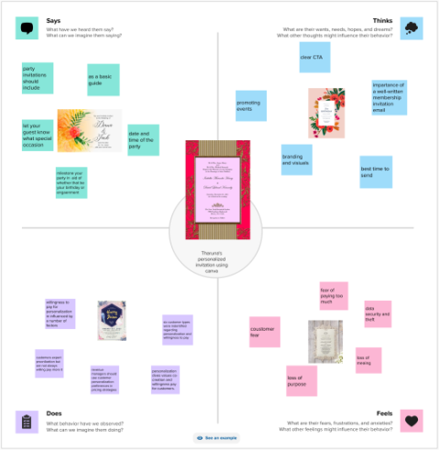

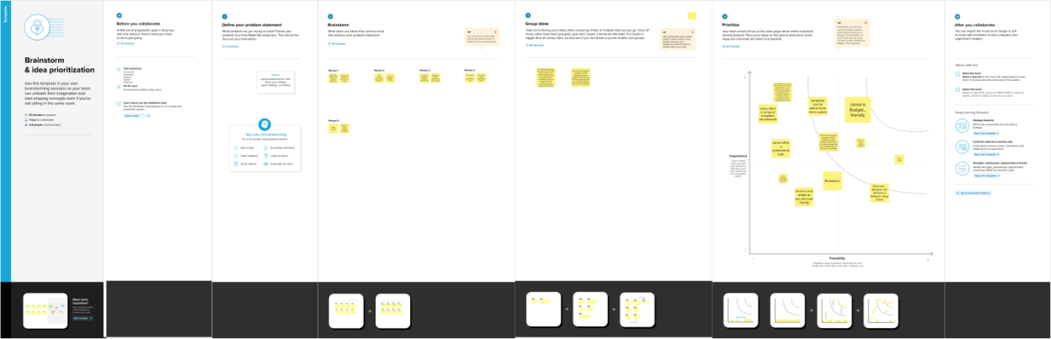



**ADVANTANGES & DISADVANTAGES**

Advantages

* Build and maintain relationships
* Create connections
* Keep it as a memory
* Build your brand
* They are informative

Disadvantages

* Formal weddings merit a formal wedding invitation.
* Email invites can be confusing.
* Your family feels unimportant.
* Nobody receives an invite!

**APPLICATION**

* Open Canva. Launch Canva and search for "Invitation." ...
* Look for the best template. Narrow down your search by specifying the specific occasion the invite is for. ...
* Add images and text. Use the drag-and-drop tool to select image, illustration, or other elements and move them to your design. ...
* Customize a bit more. ...

Print or share.

**CONCLUSION**

A well-designed invitation sets the stage for a memorable celebration and entices guests to mark their calendars. Whether you opt for a humorous approach, a sentimental touch, or a formal tone, ensure that the wording reflects the spirit of the birthday person and the party theme.

**FUTURE SCOPE**

An invitation card is a tool to invite people too your special events such us birthday party, Anniversary party, wedding party etc. However, everyone wants to be an important person that others take on intrest to invite into the party.